Experiment – 8

**Aim: Design an Arduino circuit to interface the TMP36 temperature sensor.**

# Components

* Arduino Uno R3
* Small Breadboard
* Jumper cable
* TEMP36

# Theory

1. **Arduino Uno R3**

An open-source microcontroller board used to control electronic components and execute programmed instructions.

1. **Small Breadboard**

A compact, reusable board for prototyping circuits without soldering, allowing easy component connections.

1. **Jumper Cable**

Flexible wires used to establish electrical connections between components on a breadboard or to an Arduino.

1. TMP36 Temperature Sensor

An analog temperature sensor that provides a voltage output proportional to temperature.

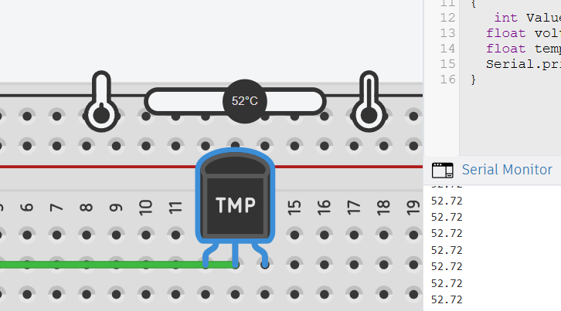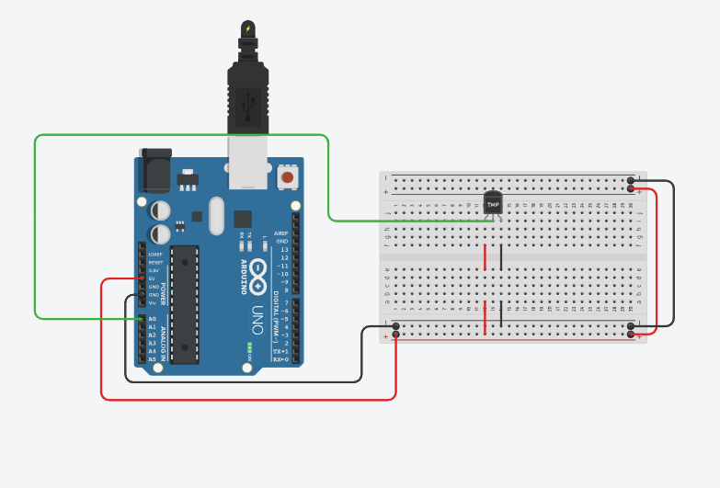Circuit Design

**Procedure to Design a Light-Controlled Circuit using a Slide Switch and Arduino on Tinkercad**

**Step 1: Add Components to the Workspace**

1. Add an Arduino Uno R3 to the workspace.
2. Place a small breadboard next to the Arduino.
3. Add a bulb to the breadboard.
4. Position a slide switch on the breadboard.
5. Use jumper cables to establish proper connections between the components.

**Step 2: Build the Circuit Connections**

**Power Supply Connections:**

1. Connect the 5V pin of the Arduino to the positive rail of the breadboard.
2. Connect the GND pin of the Arduino to the negative rail of the breadboard.

**Slide Switch Connections:**

1. Connect the common terminal of the slide switch to one side of a 10kΩ resistor (which is connected to GND) and to the positive rail (VCC).
2. Connect Terminal 1 of the slide switch to one terminal of the bulb via a jumper cable.
3. Connect Terminal 2 of the slide switch to the other terminal of the bulb via a jumper cable.

**Bulb Connections:**

1. Connect one terminal of the bulb to Terminal 1 of the slide switch.
2. Connect the other terminal of the bulb to the negative rail (GND) of the breadboard.

**Step 3: Code**

void setup() {

pinMode(A0, INPUT);

Serial.begin(9600);

Serial.println("Hello");

}

void loop() {

int Value = analogRead(A0);

float voltage = (Value / 1023.0) * 4.98;

float temp = (voltage - 0.5) * 100.0;

Serial.println(temp);

}

**Step 4: Simulate the Circuit**

1. Click "Start Simulation" in Tinkercad.

2. Adjust the light intensity on the LDR (drag the light source in simulation).

3. Observe how the LED and relay switch ON in darkness and OFF in bright light.

**Conclusion**

This experiment demonstrates how a slide switch can be used to manually control a bulb. By sliding the switch, the circuit is either completed or broken, allowing or stopping the flow of current to the bulb.